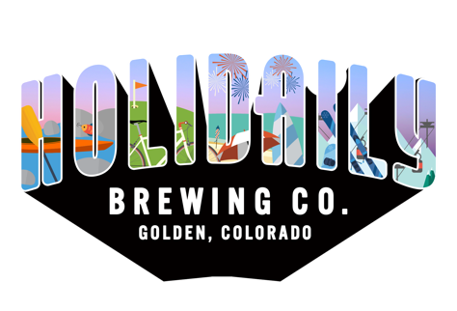

FOR IMMEDIATE RELEASE

MEDIA CONTACT:
Kaitlyn Gipple
Holidaily Brewing Co.
402-689-6253
kgipple@holidailybrewing.com

Grouse Malt House Undergoes Major Upgrades to Keep Up with Holidaily's New Gluten-free Brewery
Holidaily Brewing, Colorado’s dedicated gluten-free brewery, and Grouse Malt House, a certified gluten-free malting company in Wellington, Colorado both underwent major expansions earlier this month in response to a growing gluten-free beer demand.
From the inception of Holidaily’s first brewery in 2016, they have relied on Grouse to provide the gluten-free malted grains that make Holidaily’s beer not only great-tasting but also safe for Celiac and gluten-sensitive consumers.
“When opening a gluten-free brewery, the biggest obstacle is finding certified gluten-free grains to brew with in place of barley and wheat,” said Karen Hertz, founder of Holidaily. “We are fortunate to be just down the road from the largest gluten-free malting company in the country.”
Grouse has doubled their production every year since opening in 2013 and Holidaily has experienced similar growth, doubling and tripling their production every year since opening in 2016. This year, they both met maximum capacity.
On May 4th, the three-year old brewery in Golden opened the doors to their second brewery, now the largest dedicated gluten-free production brewery in the U.S. The new brewery tripled their capacity initially with room for future growth in the 10,000 square-foot facility.
Because of Holidaily’s expansion, Grouse Founder and CEO Twila Soles installed a combination germination/kiln vessel, doubling their malting capacity and allowing them to provide the additional grain Holidaily needed for their 65-barrel facility.
“Our main focus at Grouse is equipping breweries like Holidaily with the ingredients they need to brew great-tasting, gluten-free beer,” said Soles. “This goal motivated me to start Grouse initially, and the increasing demand for our products drives our team to keep growing.”
Up until now, Holidaily self-distributed their beer to over 300 accounts throughout Colorado including stadiums and grocery stores. With the opening of the new facility, Holidaily has signed on with various distributors throughout Colorado, including Coors Distributing Company in Denver and High Country Beverage out of Johnstown. This will allow Holidaily to expand their footprint in Colorado, selling to more retailers, bars, restaurants and even other breweries. Holidailybrewing.com/buy/
What’s next for Holidaily and Grouse?
Holidaily will focus on expanding their distribution to all four corners of Colorado with the potential to eventually look at distribution outside of the state. Grouse plans to grow their already existing portfolio of over 30 national and international breweries that use their gluten-free grain. Of course, all of this while continuing to supply Holidaily’s trajectory.
About Holidaily Brewing Company:
Of the over 7,000 craft breweries in the nation, Holidaily is one of just 12 dedicated gluten-free breweries and of those, the only woman-owned. Holidaily opened in Golden in 2016 and is the passion project of Karen Hertz, who survived both melanoma and thyroid cancer, leading to a treatment regimen including a gluten-free diet.
Hertz struggled to find a great tasting, 100% gluten-free beer and was driven to solve this problem. After years of research and testing, Holidaily Brewing Company was born.
Their taproom is located in Golden, Co. at 801 Brickyard Circle with the new production facility across the street. Beers are distributed to liquor stores, restaurants, stadiums, grocery stores and breweries throughout Colorado. www.HolidailyBrewing.com
About Grouse Malt House:
When Grouse Malt House CEO Twila Soles was diagnosed with Ulcerative Colitis, it was seemingly only treatable with prescription medication, until she adopted a gluten-free lifestyle and learned of its numerous benefits. Dedicated to creating a delicious gluten-free beer, which was scarce at the time, Grouse Malt House was born, and has provided all people access to high quality food and beverage since 2013. In Wellington, CO, Grouse is one of the only dedicated gluten-free malting companies in the world. Today, Twila and the Grouse team promise uncompromising integrity through a network of tenacious individuals who share a vision of collaboration, transparency, and dedication to deliver artisan products that everyone is free to fully enjoy.

